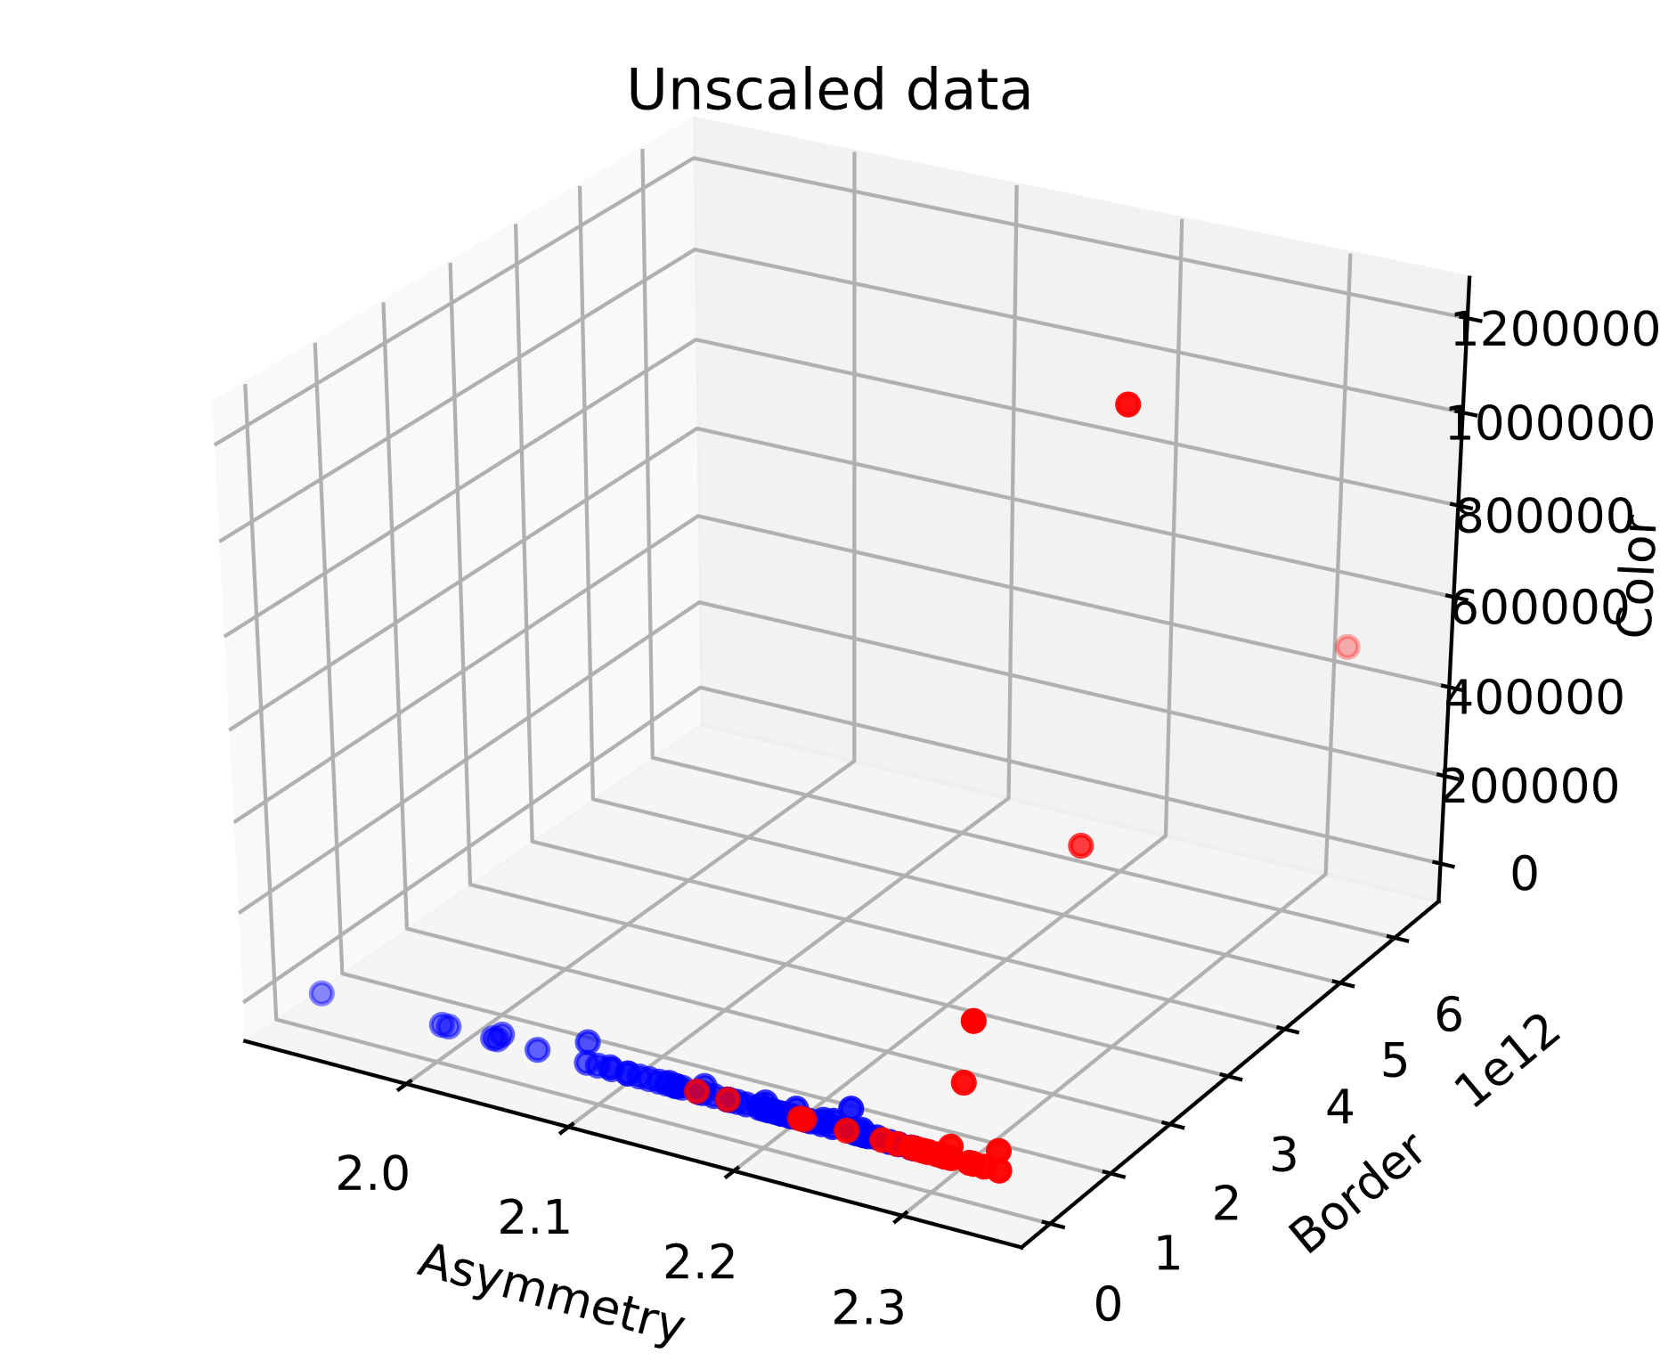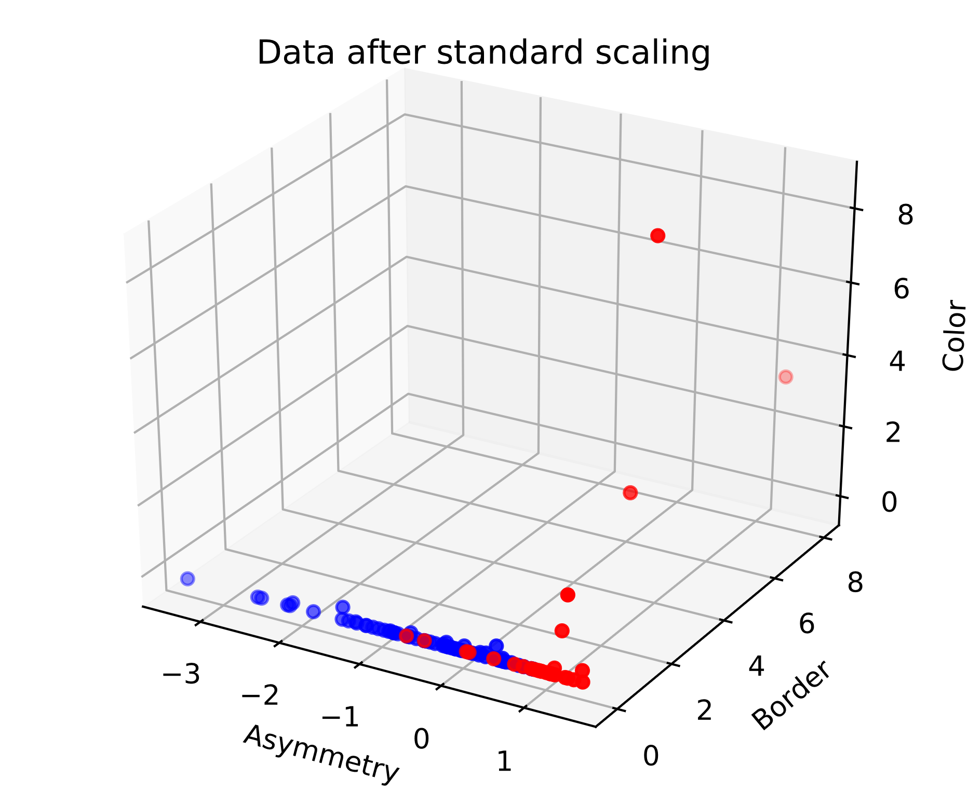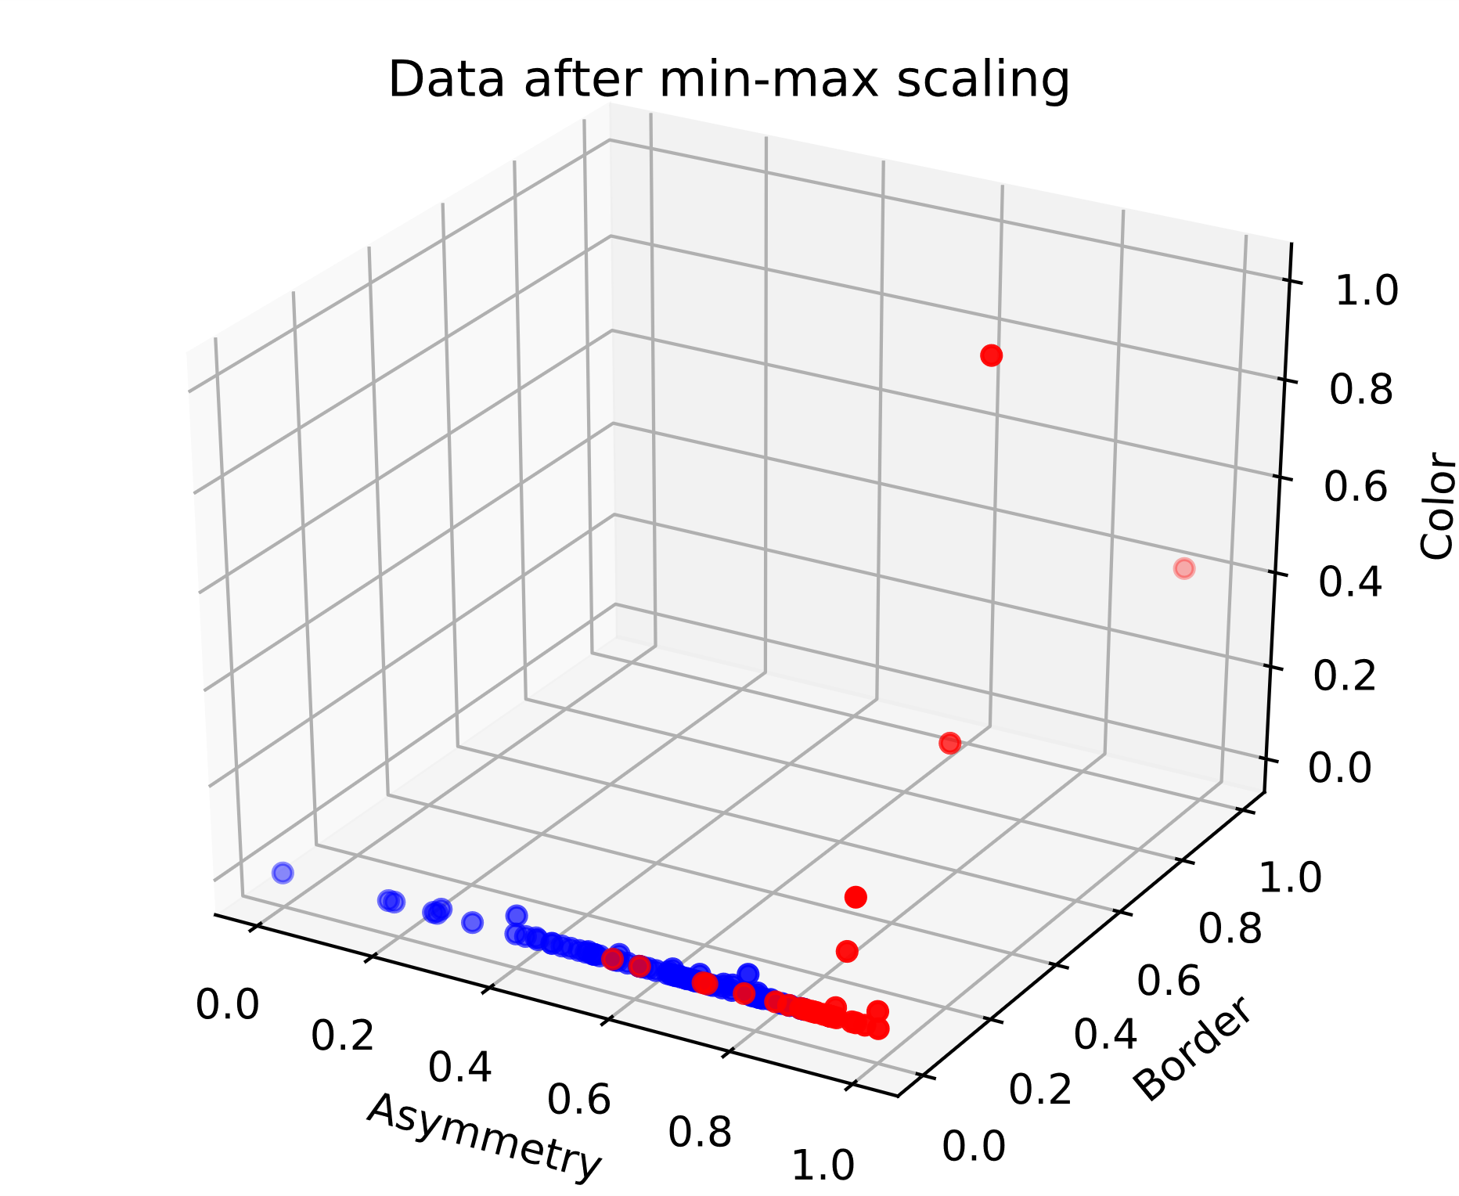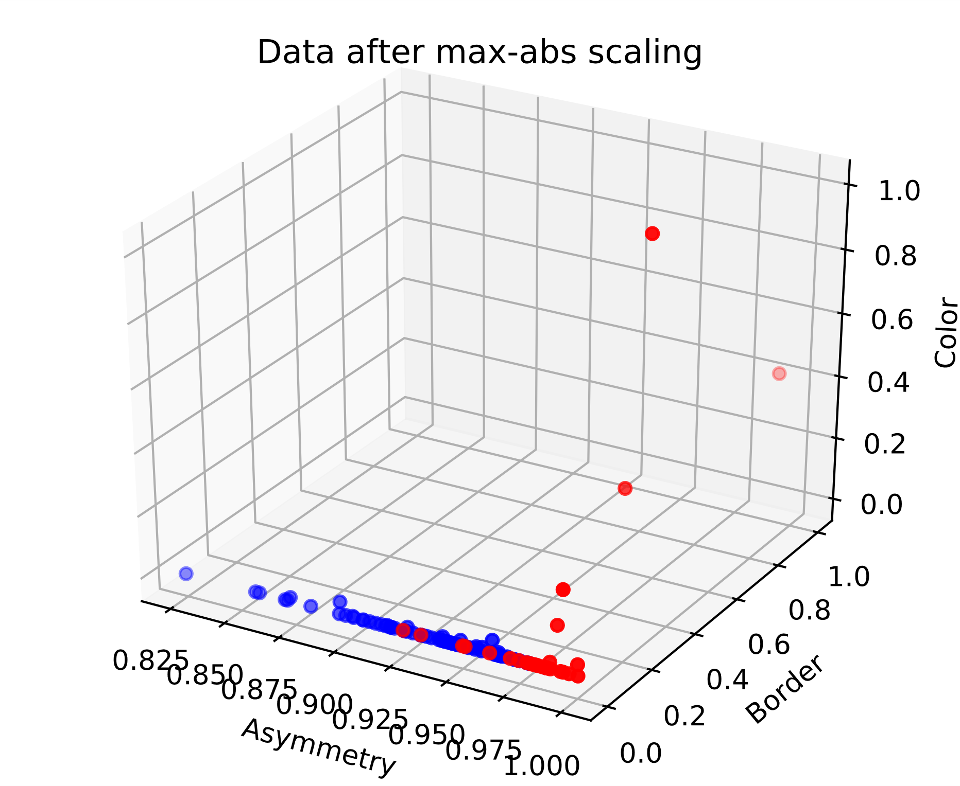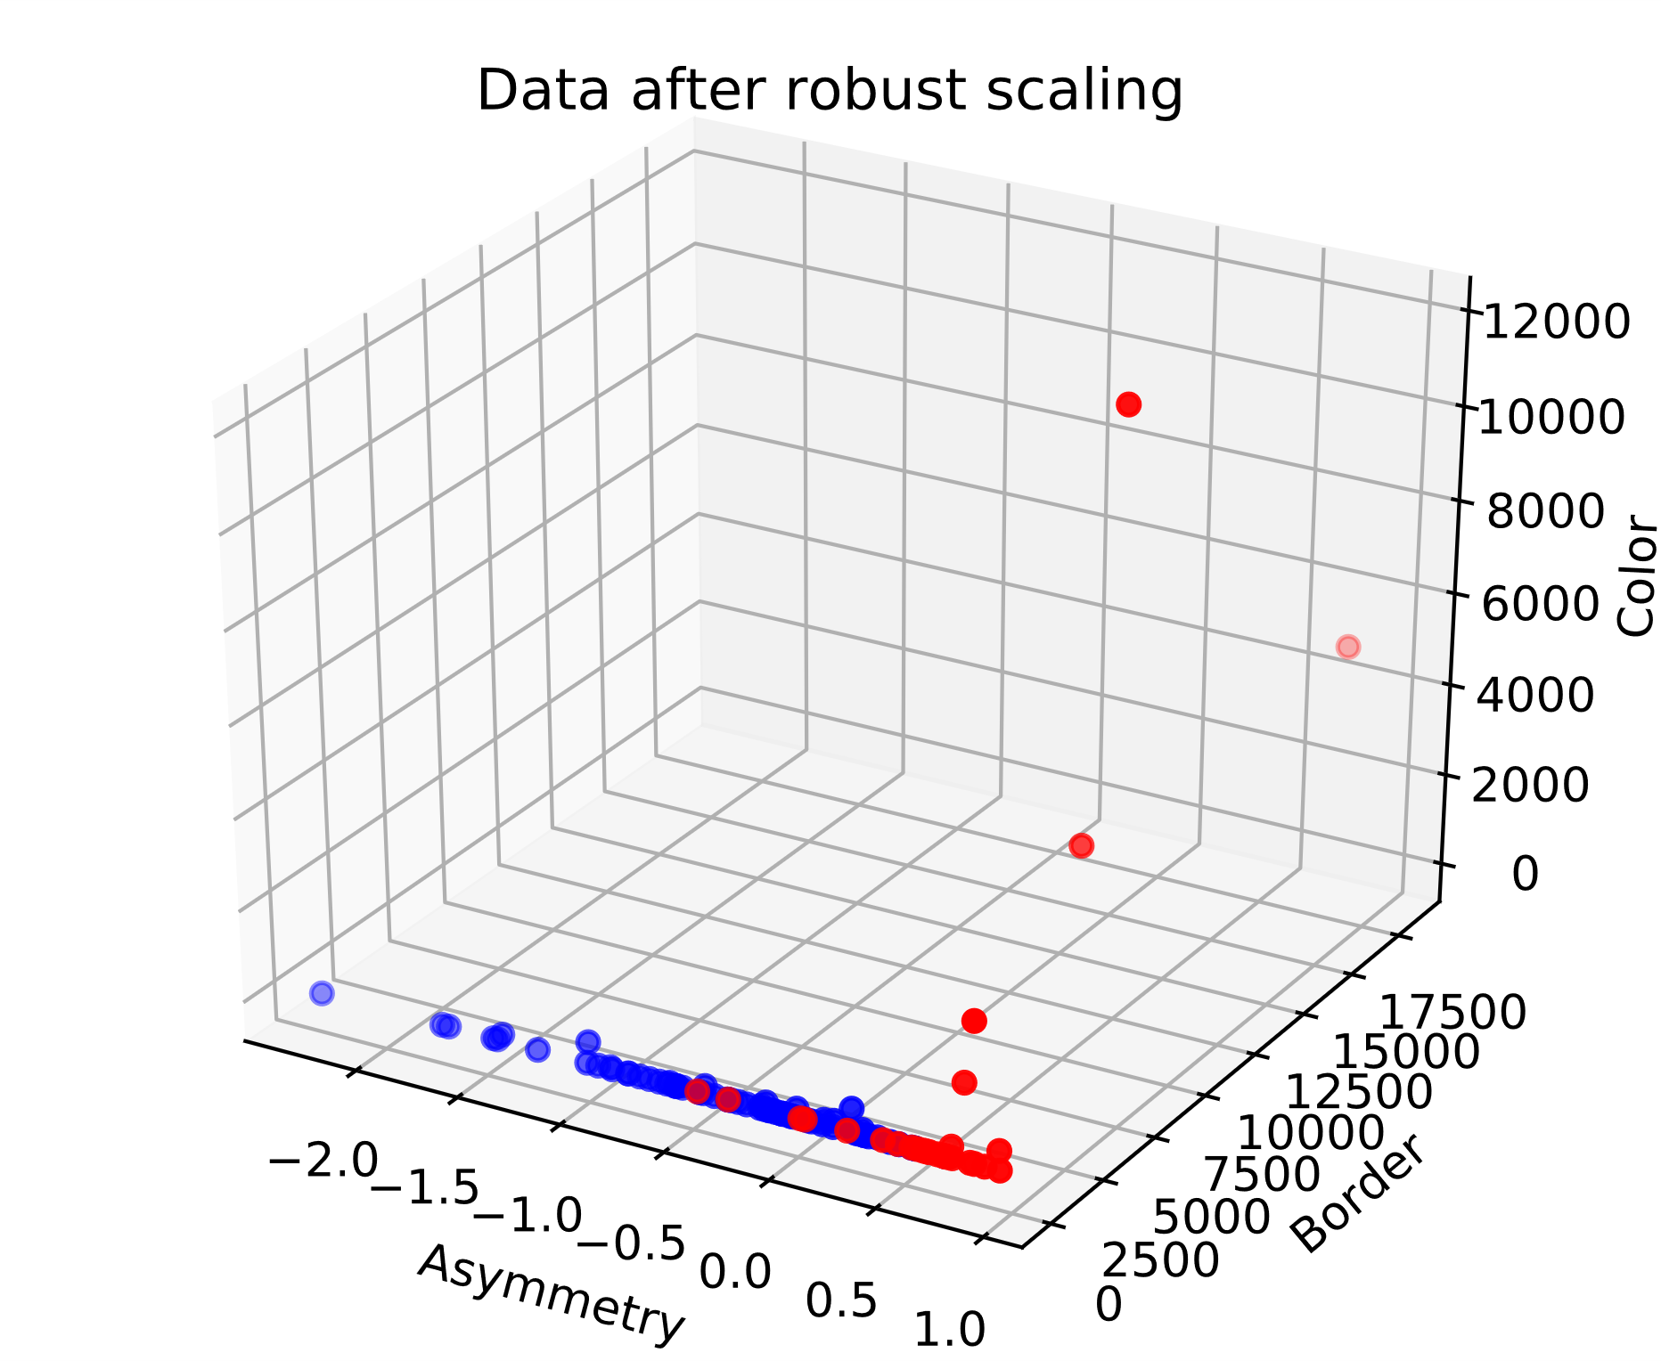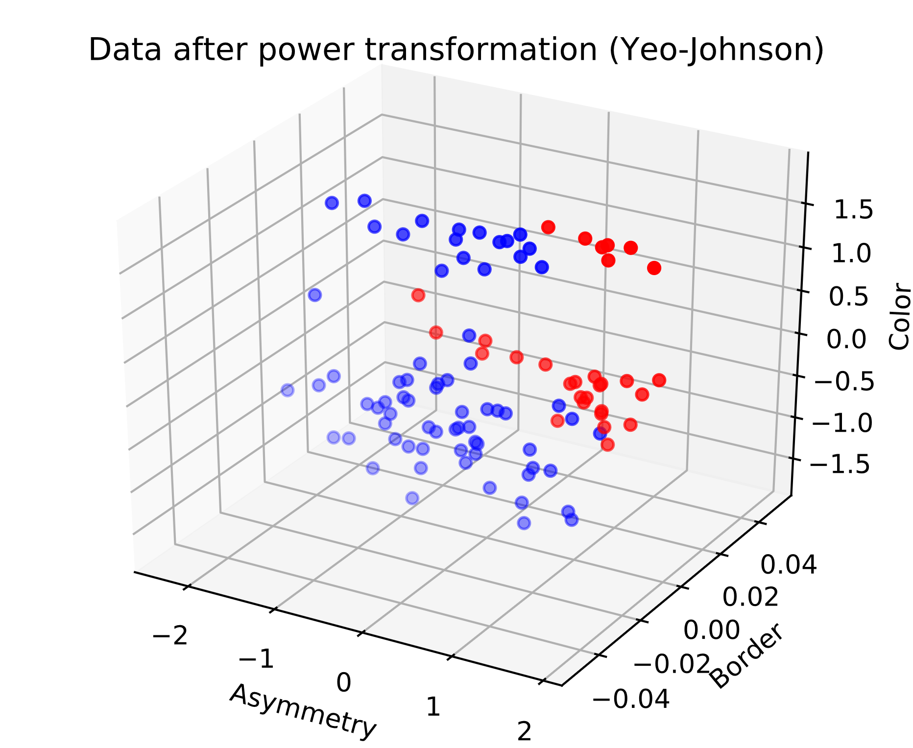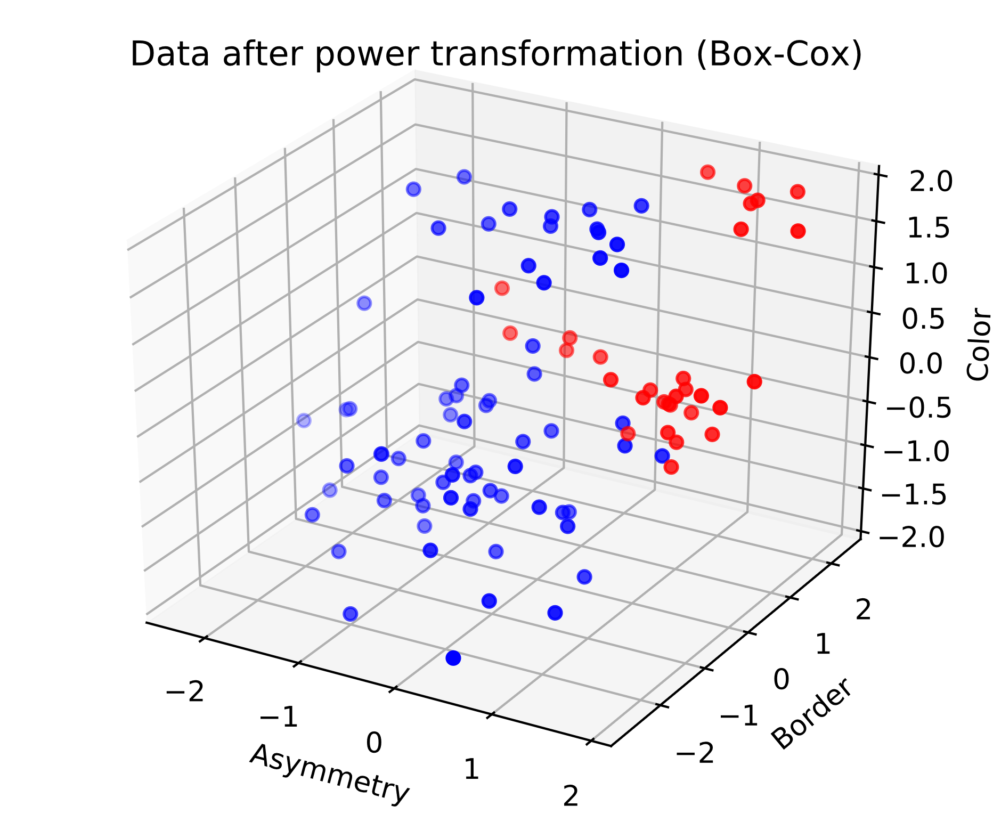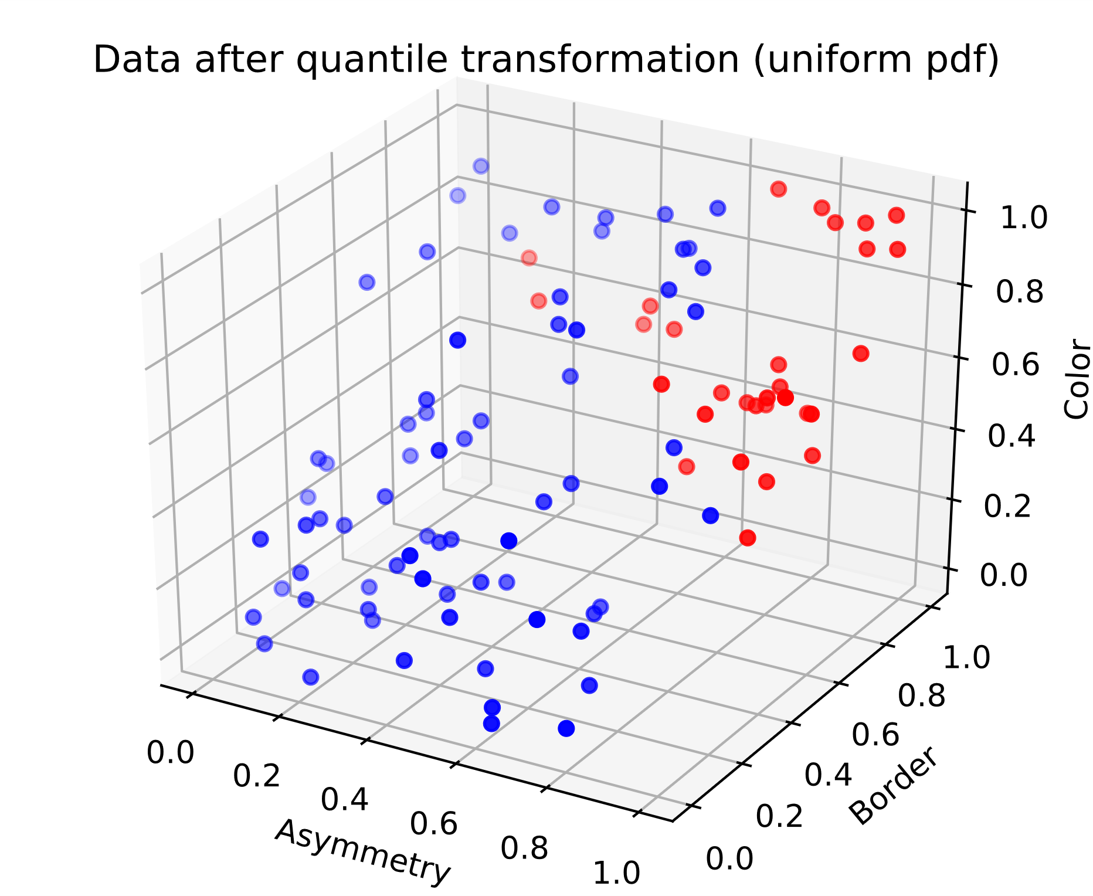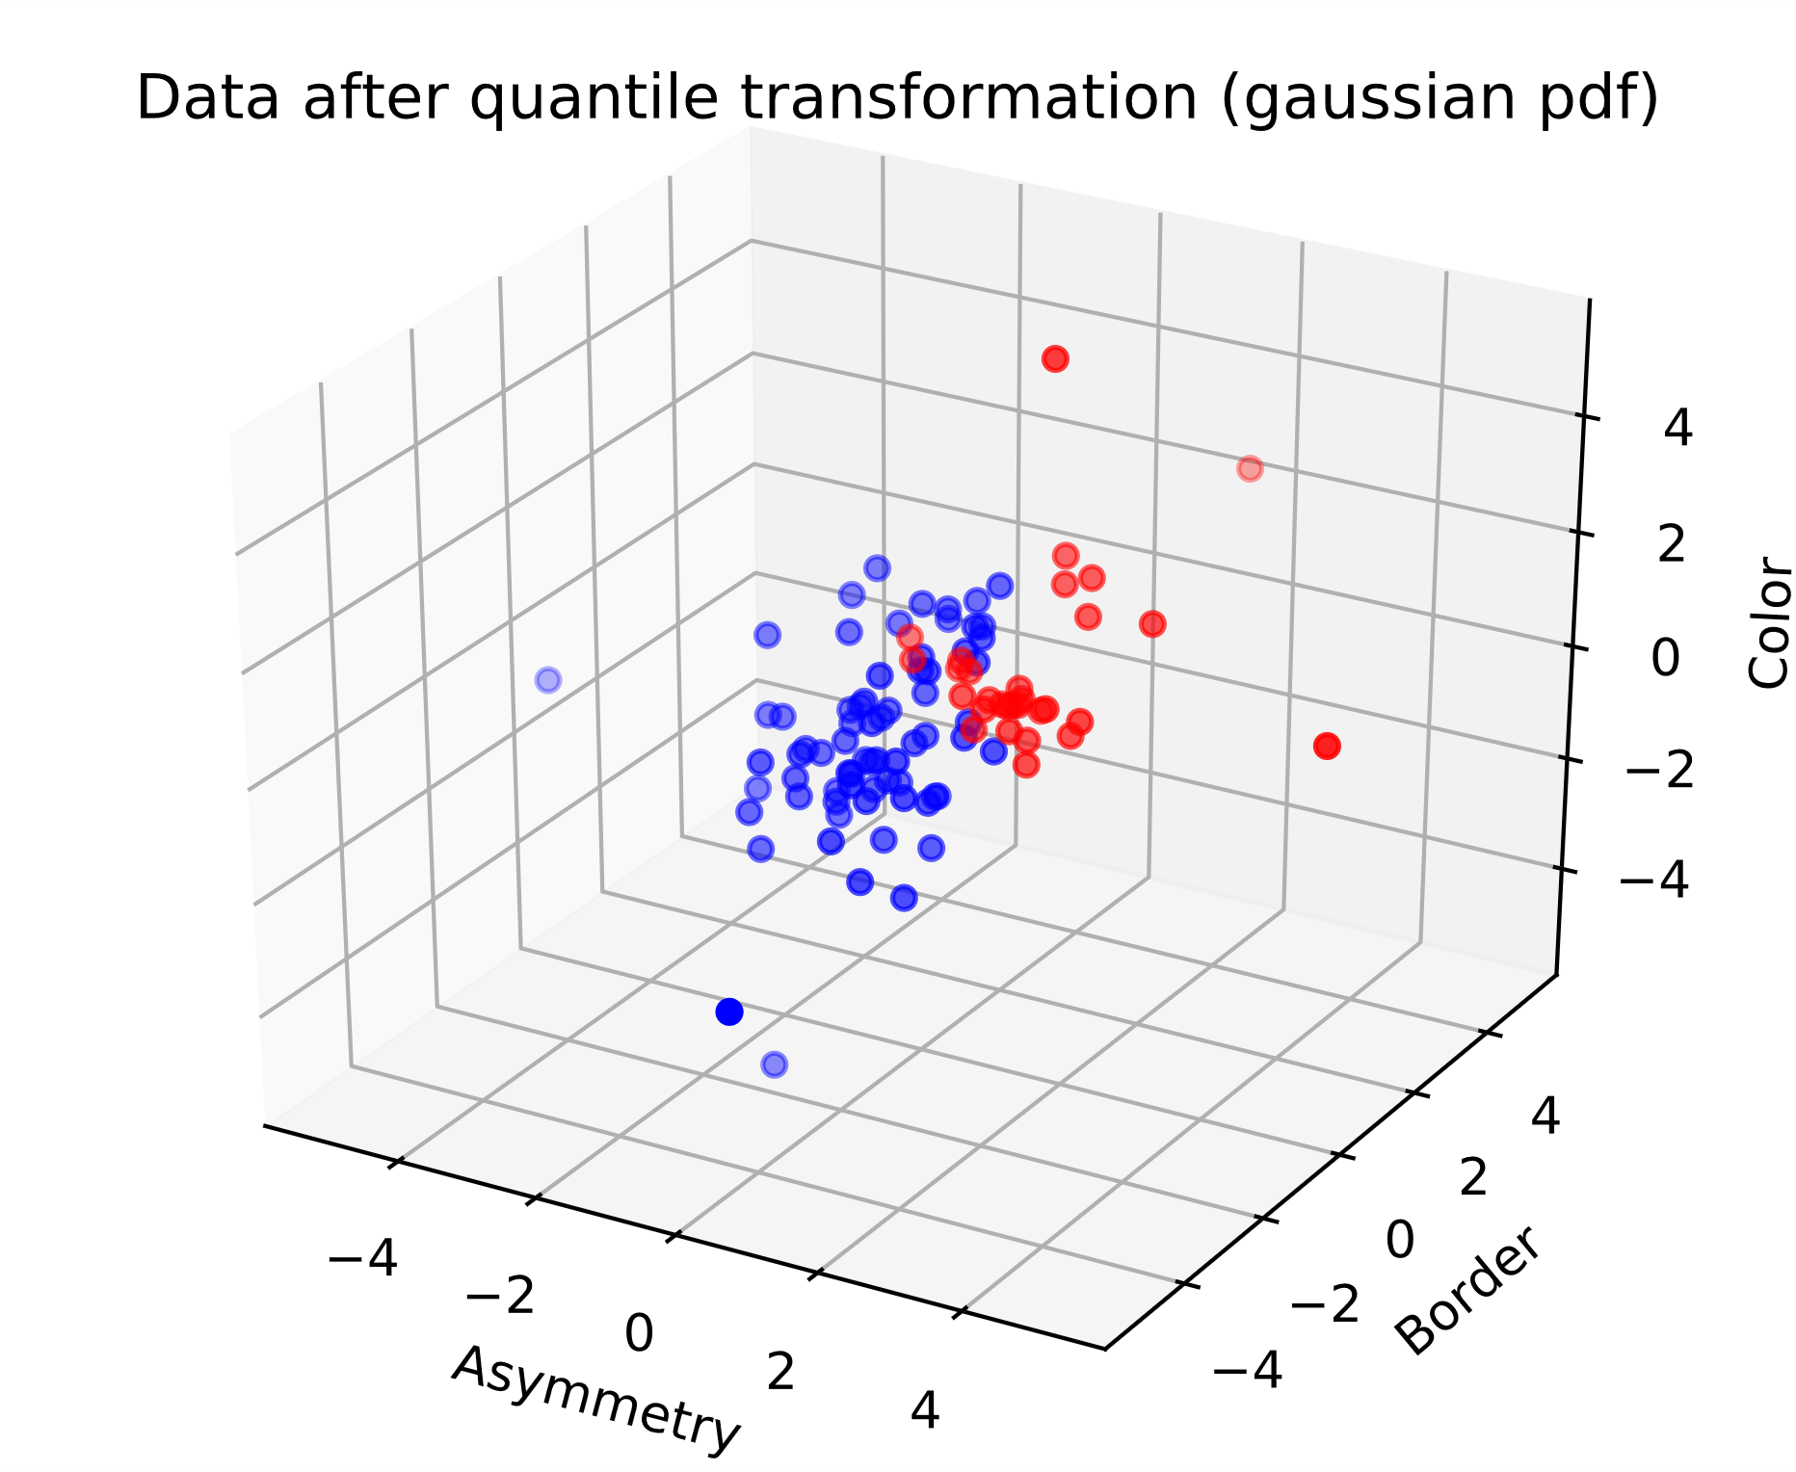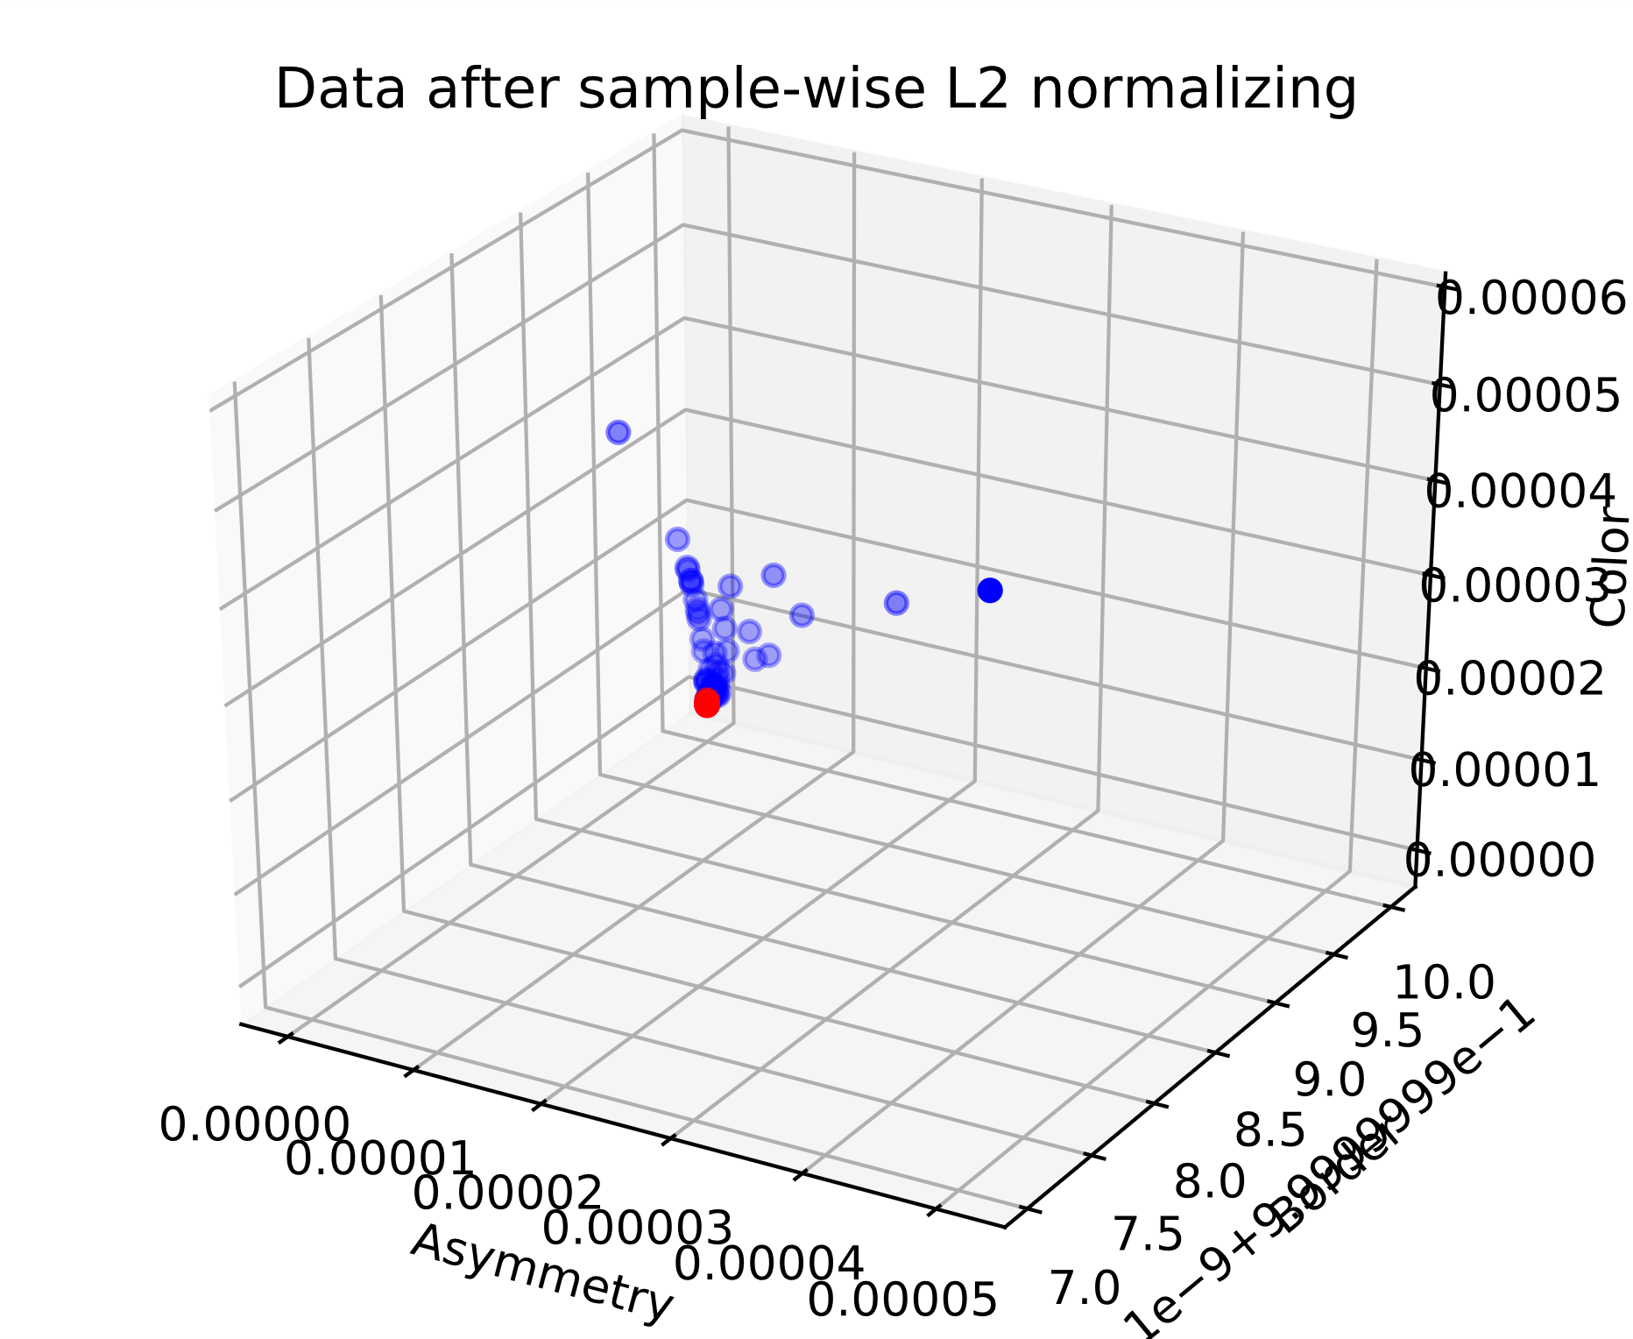

Na duizend keer runnen zijn dit gemiddelde accuracies.

Unscaled data has accuracy 0.7887000000000007

Data after standard scaling has accuracy 0.7856499999999993

Data after min-max scaling has accuracy 0.7888999999999988

Data after max-abs scaling has accuracy 0.7883999999999991

Data after robust scaling has accuracy 0.7863000000000002

Data after power transformation (Yeo-Johnson) has accuracy 0.7862499999999997

Data after power transformation (Box-Cox) has accuracy 0.7915499999999998

Data after quantile transformation (uniform pdf) has accuracy 0.7879999999999994

Data after quantile transformation (gaussian pdf) has accuracy 0.7897000000000004

Data after sample-wise L2 normalizing has accuracy 0.7913999999999998

Min max scaler is gevoelig voor outliers.

Not normally distributed standard scaling.

Qua accuracy maakt het niet uit dus voor allemaal juiste factoren vinden

**Unscaled data**

Hoogste percentage: 1.0 met Kleur factor = 0.1 , Symmetrie factor = 0.2 en Border Factor = 0.6000000000000001

**Data after standard scaling',**

Hoogste percentage: 0.95 met Kleur factor = 0.30000000000000004 , Symmetrie factor = 3.7 en Border Factor = 2.8000000000000003

**Data after min-max scaling**

Hoogste percentage: 0.95 met Kleur factor = 0.6000000000000001 , Symmetrie factor = 0.8 en Border Factor = 2.9000000000000004

**Data after max-abs scaling'**

Hoogste percentage: 0.95 met Kleur factor = 0.1 , Symmetrie factor = 0.8 en Border Factor = 2.4000000000000004

**Data after robust scaling**

Hoogste percentage: 0.95 met Kleur factor = 0.1 , Symmetrie factor = 0.4 en Border Factor = 1.4000000000000001

**Data after power transformation (Yeo-Johnson)**

Hoogste percentage: 1.0 met Kleur factor = 2.3000000000000003 , Symmetrie factor = 1.8 en Border Factor = 1.6

**Data after power transformation (Box-Cox)**

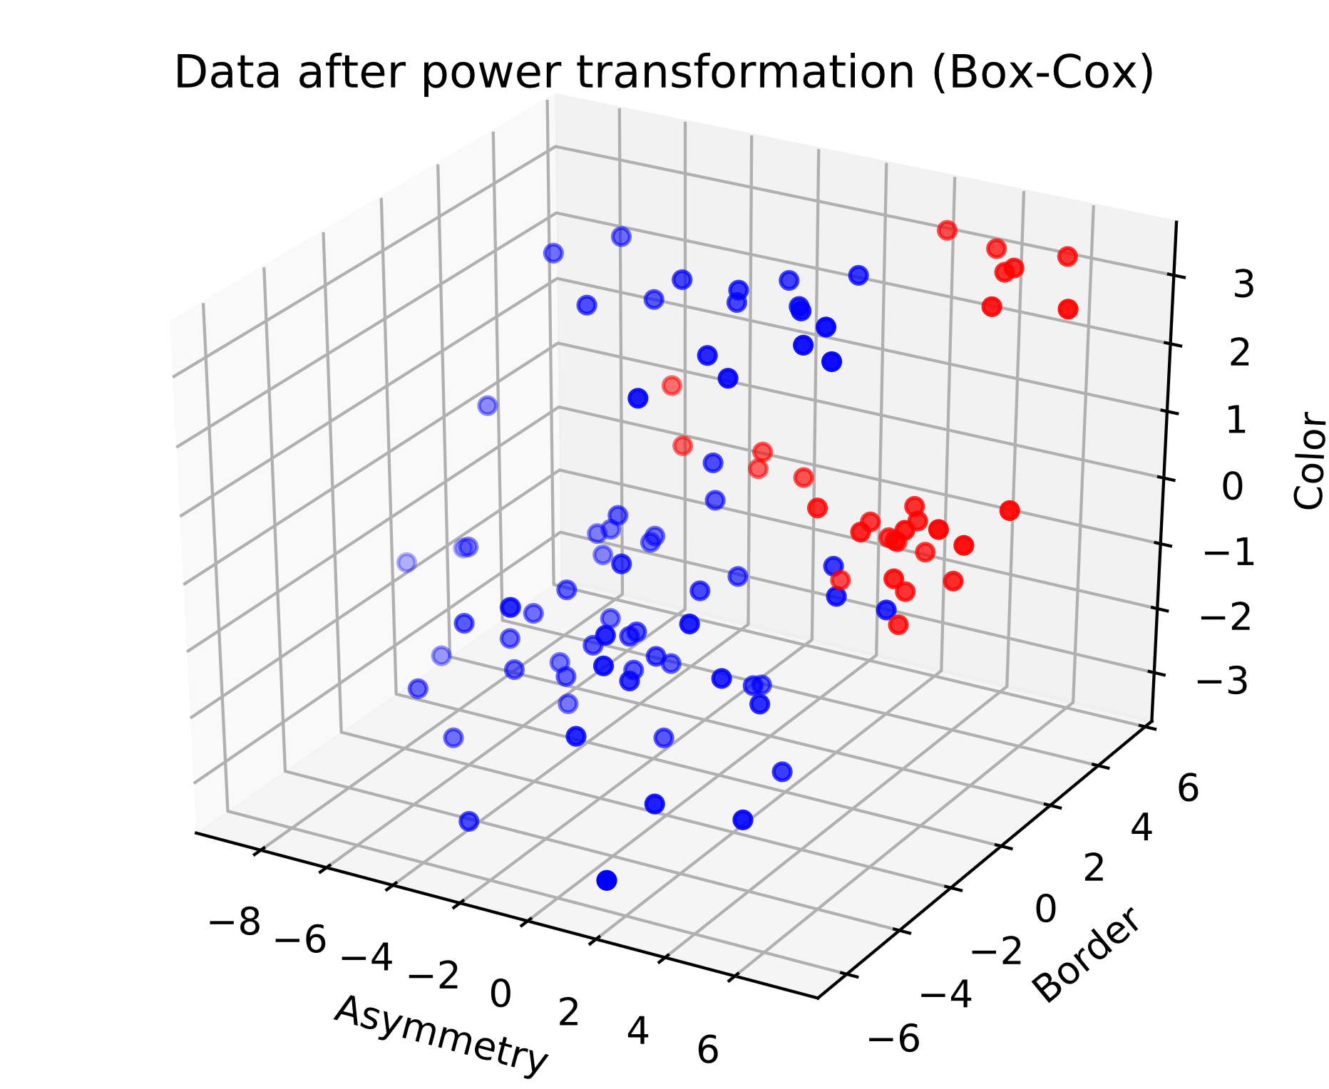

Hoogste percentage: 1.0 met Kleur factor = 1.6 , Symmetrie factor = 2.0 en Border Factor = 2.0

**Data after quantile transformation (uniform pdf)**

Hoogste percentage: 0.95 met Kleur factor = 0.2 , Symmetrie factor = 0.8 en Border Factor = 3.2

**Data after quantile transformation (gaussian pdf)**

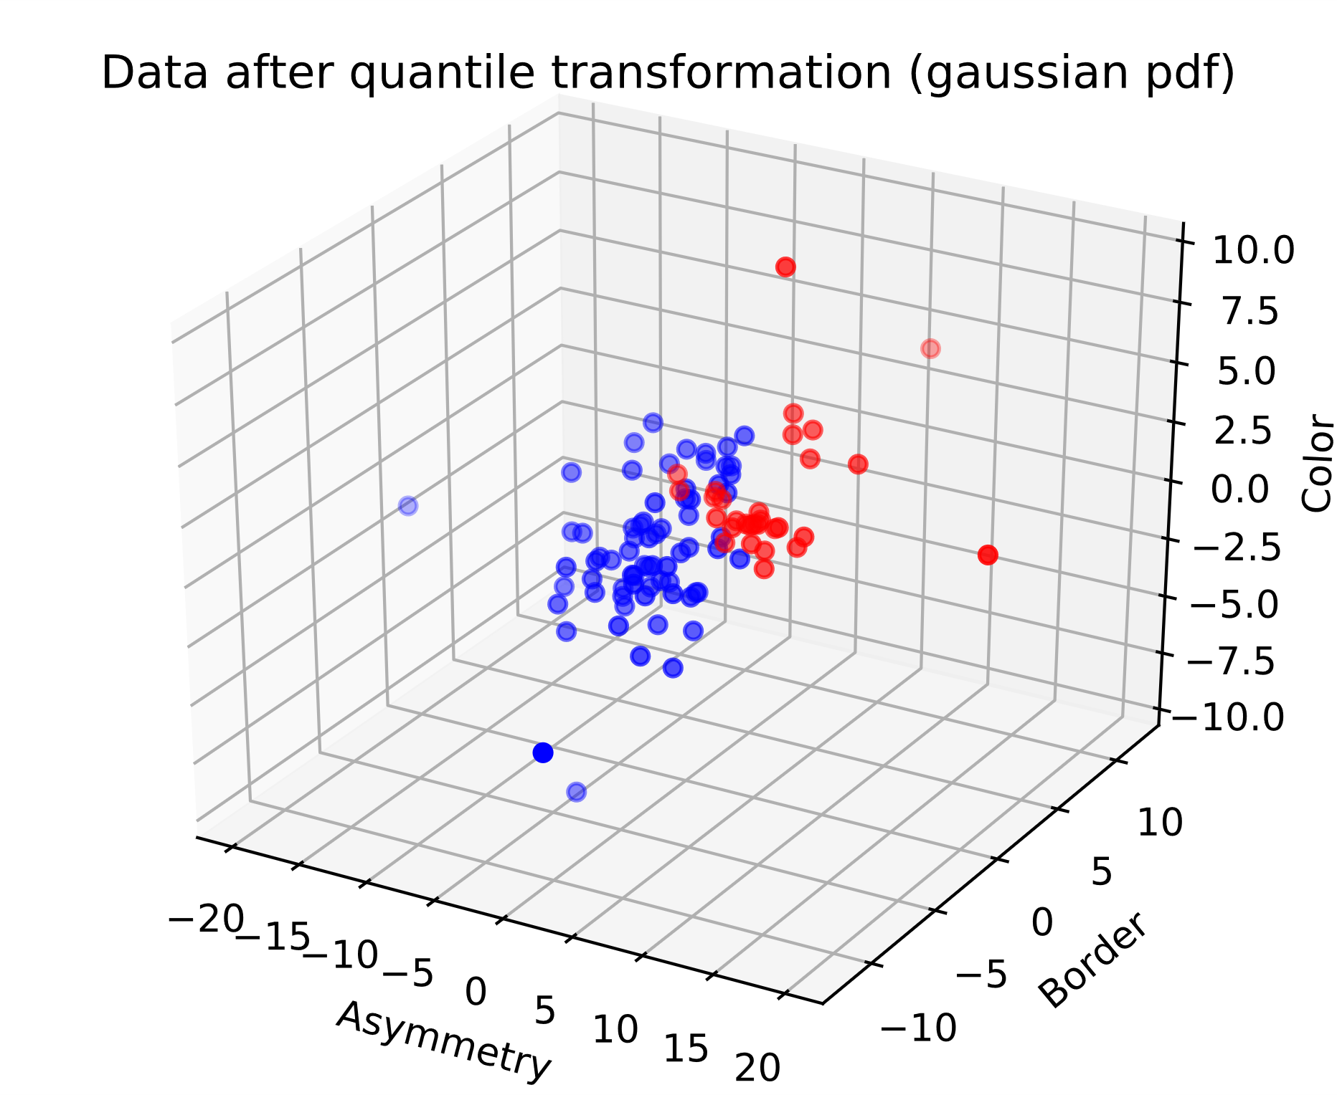

Hoogste percentage: 1.0 met Kleur factor = 1.8 , Symmetrie factor = 2.3000000000000003 en Border Factor = 3.8000000000000003

**Data after sample-wise L2 normalizing**

Hoogste percentage: 1.0 met Kleur factor = 1.6 , Symmetrie factor = 2.9000000000000004 en Border Factor = 0.8

**Conclusie op het einde:**

Hoogste percentage: 1.0 met Kleur factor = 1.6 , Symmetrie factor = 2.0 en Border Factor = 2.0

Met Box-Cox ook mooiste grafiek van dingen die gescheiden zijn.